VOICE RECORDING AND PLAYBLACK
USING APR9600 CHIP

APR 9600 Features:

• Single-chip, high-quality voice recording & playback solution
- No external ICs required
- Minimum external components

• Non-volatile Flash memory technology
- No battery backup required

• User-Selectable messaging options
- Random access of multiple fixed-duration messages
- Sequential access of multiple variable-duration messages

• User-friendly, easy-to-use operation
- Programming & development systems not required
- Level-activated recording & edge-activated play back switches

• Low power consumption
- Operating current: 25 mA typical
- Standby current: 1 uA typical
- Automatic power-down

• Chip Enable pin for simple message expansion

APR9600 BLOCK DIAGRAM

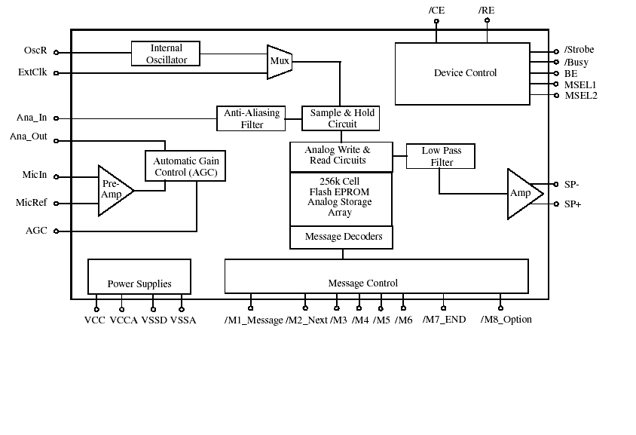 Functional Description

The APR9600 block diagram is included in order to give understanding of the APR9600 internal architecture. At the left hand side of the diagram are the analog inputs. A differential microphone amplifier, including integrated AGC, is included on-chip for applications requiring its use. The amplified microphone signal is fed into the device by connecting the An Out pin to the An a In pin through an external DC blocking capacitor. Recording can be fed directly into the An a In pin through a DC blocking capacitor, however, the connection between An a In and An a Out is still required for playback.

The next block encountered by the input signal is the internal anti-aliasing filter. The filter automatically adjusts its response according to the sampling frequency selected so Shannon’s Sampling Theorem is satisfied. After anti-aliasing filtering is accomplished the signal is ready to be clocked into the memory array. This storage is accomplished through a combination of the Sample and Hold circuit and the Analog Write/Read circuit. These circuits are clocked by either the Internal Oscillator or an external clock source.

When playback is desired the previously stored recording is retrieved from memory, low pass filtered, and amplified as shown on the right hand side of the diagram. The signal can be heard by connecting a speaker to the SP+ and SP- pins. Chip-wide management is accomplished through the device control block shown in the upper right hand corner. Message management is controlled through the message control block represented in the lower center of the block diagram.

More detail on actual device application can be found in the Sample Applications section. More detail on sampling control can be found in the Sample Rate and Voice Quality section. More detail on message management and device control can be found in the Message Management section.

CIRCUIT DIAGRAM OF APR 9600

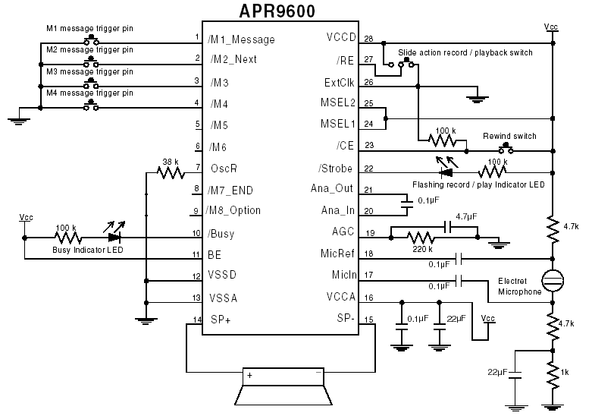

APR9600 single chip voice recorder and playback device from Aplus Integrated circuits makes use of a proprietary analogue storage technique implemented using flash non-volatile memory process in which each cell is capable of storing up to 256 voltage levels. This technology enables APR9600 to reproduce voice signals in their natural form.

The APR9600 is a good standalone voice recorder or playback IC with non-volatile storage and playback capability for 32 to 60.It can record and play multiple messages at random or in sequential mode. The user can select sample rates with consequent quality and recording time trade-off. Microphone amplifier, automatic gain control (AGC) circuit, internal anti-aliasing filter, integrated output amplifier and messages management are some of the features of the APR9600 chip.

Voice signal from the microphone is fed into the chip through the differential amplifier. It is further amplified by connecting Ana_Out via an external DC blocking capacitor. A bias signal applied to the microphone and to save power during playback, the ground return of this bias network can be connected to the normally open side of the record switch. Both Mic.in and Mic.ref (Pin18 and Pin19) must be coupled to the microphone network through capacitors.

Recording signal from the external source can also be fed directly into the chip using Ana_In (Pin20), but the connection between Ana_In (Pin20) and Ana_Out (Pin21) is still required for playback. An internal anti_aliasing filter automatically adjusts its response according to the sampling frequency selected. Then the signal is processed into the memory array through a combination of the sample and hold circuit and analogue read/write circuit. The incoming voice signals are sampled and the instantaneous voltage samples are stored in the nonvolatile flash memory cells in 8-bit binary encoded format.

During playback, the stored signals are retrieved from the memory, smoothed to form a continuous signal, low pass filtered and then amplified. The signal level at the speaker terminals SP+ and SP- (Pins 14 and 15 respectively) is at about 12mV power into 16Ohm impedance. The output from Pin 14(SP+) is further amplified by the low power amplifier using LM386.The recorded message is reproduced into speaker LS1.

An internal oscillator provides sampling clock to the APR9600.The frequency of the oscillator and sampling rate depend on the value of resistor R12 [R12(A) + R12(B)] connected across OSCR (Pin 7) of the chip and the ground.
Table 2nd shows the sampling frequencies corresponding to different resistor values, as well as the resulting input bandwidth and duration of recording. Higher sampling rates improve the quality but they also increase the bandwidth requirement and thus reduce the duration. Lower sampling rates use fewer memory cells and effectively increase the recording/playback duration of the device. The RC network at Pin 19 sets the AGC attack time. (The attack time defined as the delay present before the AGC circuit begins to adjust gain.)

RANDOM ACCESS MODE:

As mentioned earlier, the random access mode supports 2,4or 8 messages of fixed durations. It allows easy indexing of messages as they can be recorded or played randomly. The length of each message is the total recording
length available divided by the total number of memory segments /tracks enabled.

Recording of sound: The circuit for recording/playback of eight fixed duration messages in random access mode is shown in fig. Pins 9(M8_Option), 24(MSEL1) and 25(MSEL2) are pulled high through resistors R1, R6 and R5,
respectively. When switch S10 is closed, record Pin 27 (RE) goes low to enable recording of the message from the microphone. The maximum length of the eight sound tracks is 7.5 seconds each.

Now to start recording the first message, press switch S1 and holds it in this position. A beep sound is heard and LED2 blinks. You can now speak into the condenser mic. The recording will terminate if switch S1 is released or if the recording time exceeds 7.5 seconds. Similaraly, press switches S2 through S8 to record other sound tracks. For recording of two or four sound tracks of fixed duration, the status of Pins 9, 24 and 25 is as per Table1.

Playback of sound tracks: Open switch S10 to make Pin 27 high while keeping other switches in the same positions as in recording .Toggling switches S1 through S8 causes playback of particular sound tracks. Pressing the same switch again or switch S9 terminates playback of the sound track. Pressing any other switch (S1 through S8) while a sound track is being played causes a new sound track to be played. If the switch is held pressed, the particular sound track will play continuously.

The input signal generated for voice processor is from microcontroller ports or ask receiver circuits

